Step demo

Import the json file collection to Postman

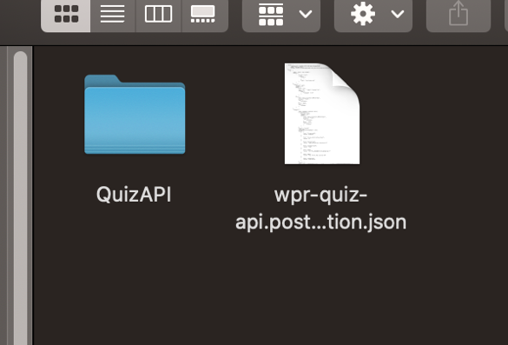

After import, run the POST insert data http

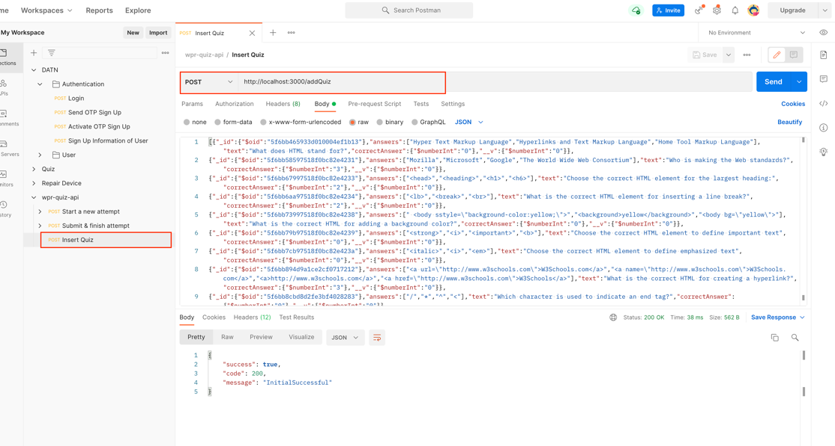

If the status is 200, the server just created the answers collections. Next, we call the server to start attempt

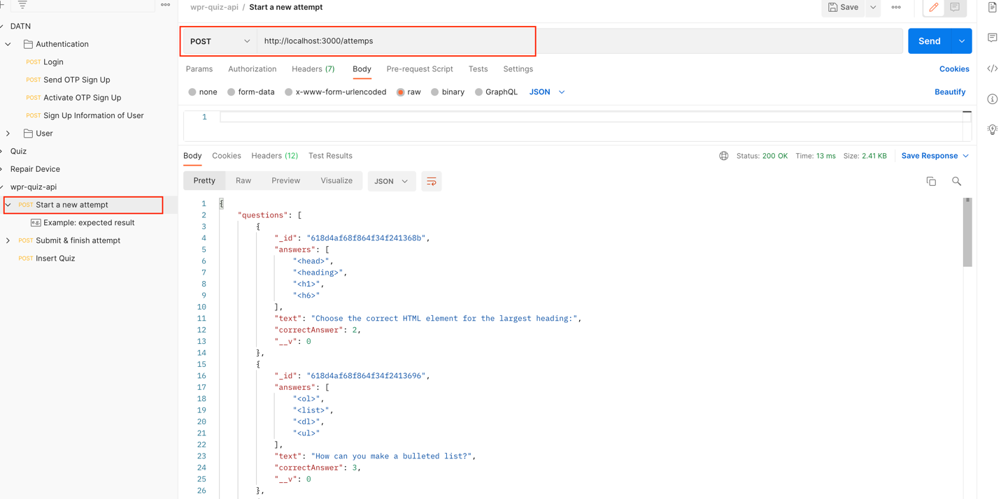

When submit attempt, just add id was receive in previous response to the path and the format data below

Id to the path

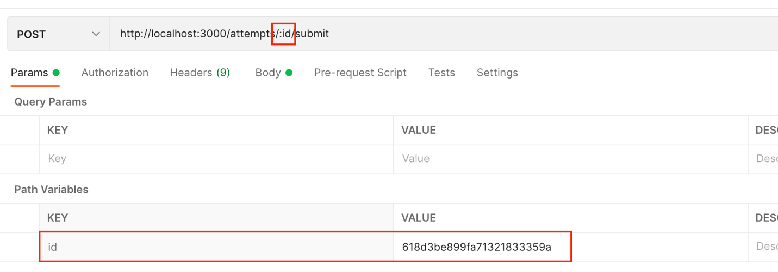

And the format data

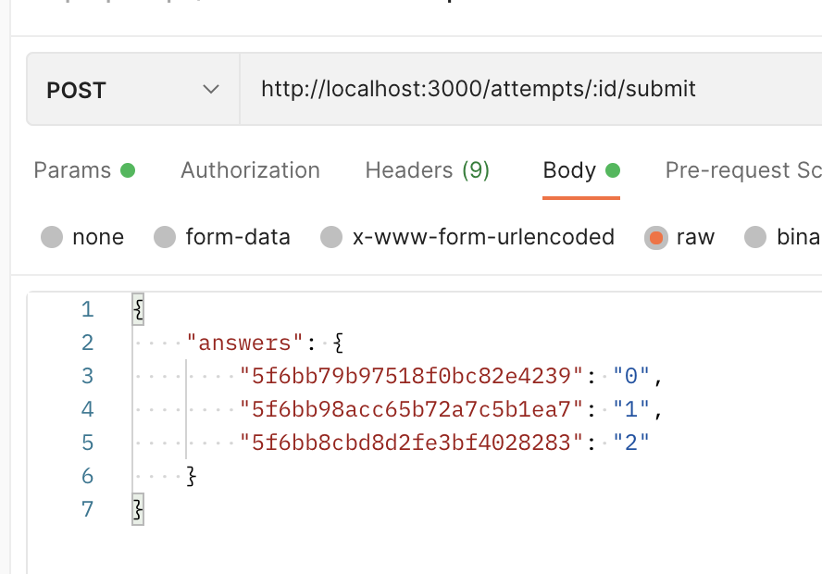

The server will return final result for this attempt. One attempt only submit once times.